

Charité International Cooperation

Welcome Package

For Mobile Researchers and Scientists

Table of Contents

WELCOME TO THE CHARITÉ - Universitätsmedizin Berlin 2
Charité International Cooperation (CHIC) 2
SOME INFORMATION ABOUT THE CHARITÉ - Universitätsmedizin Berlin 3
History of the Charité 3
MORE HELPFUL INFORMATION 4
CIPom – Free access to the Internet for students and employees 4
Meals and student cafeteria 4
Medical library 4
Working hours 4
Charité E-Mail account 4
IMPORTANT ADDRESSES – CHARITÉ 5
STAY IN BERLIN 6
Public transport 6
Cell phones 6
Life in Berlin 6
GLOSSARY 7
BEFORE LEAVING FOR BERLIN 8
AFTER YOUR ARRIVAL 8
CHARITÉ CAMPUS BENJAMIN FRANKLIN (CBF): 9
CHARITÉ CAMPUS MITTE (CCM): 10
CAMPUS CHARITÉ VIRCHOW KLINIKUM (CVK): 11
PUBLIC TRANSPORT (U-Bahn, S-Bahn, Bus, Tram): 12

WELCOME TO THE CHARITÉ - Universitätsmedizin Berlin

The Charité Welcome Center at Charité International Cooperation would like to extend you a warm welcome and wish you all the best as you begin your stay in Berlin.

This “Welcome Package” will give you a brief overview of Charité- Universitätsmedizin Berlin and your stay in Berlin. For further information please see our “Welcome Package for international students”.

You can find us here:

Charité International Cooperation (CHIC)
Welcome Center
Campus Charité Mitte (CCM), Charitéplatz 1, 10117 Berlin
On the Campus: Virchowweg 24, 3rd floor

Pamela Glowacki
CCM, Virchowweg 24, 3rd floor, room: 03 031
+49-30-450 570076 Fax: +49-30-450 576900
Email: pamela.glowacki@charite.de

Monday 10am – 1pm

Franziska Grimm
CCM, Virchowweg 24, 3rd floor, room: 03 031
+49-30-450 570077 Fax: +49-30-450 576900
Email: franziska.grimm@charite.de

Monday 10am – 1pm

Our Services:
- We provide information and guidance on a wide range of issues such as visa requirements, health insurance, family issues, and general information about the Charité- Universitätsmedizin and Berlin.

SOME INFORMATION ABOUT THE CHARITÉ - Universitätsmedizin Berlin

The Charité is one of the largest university hospitals in Europe, with 3700 doctors and scientists, working clinically, doing research and teaching at the top international level. The Charité has an international reputation for excellence in training. It extends over four campuses with almost 100 clinics and institutes bundled under 17 CharitéCenters. With 13,200 employees, the Charité is one of the largest employers in Berlin (valid as of 2014).
The four Charité campuses are Campus Mitte, Campus Virchow-Klinikum, Campus Benjamin Franklin and Campus Berlin-Buch (-> How to get there? see page 9-12).

Research
There are over 4,500 scientists at the Charité Medical Faculty engaged in pioneering biomedical research in countless projects, working groups and cooperations. The focus here is on translational interaction of experimental, molecular biological basic research with patient-oriented clinical application.

There already exist a large number of Charité research areas that are distinguished by national and international collaborative projects as well as interdisciplinary cooperations. These are the following six areas of research:

- Immunological sciences
- Cardiovascular research and metabolism
- Neurosciences
- Oncology
- Regenerative Therapies
- Rare diseases and genetics
- The “Berlin Institute of Health (BIH)”, jointly operated with the Max Delbrück Center for Molecular Medicine (MDC), complements the Charité research activities with a scientific focus on system medicine unique in Germany.

- http://www.charite.de/en/research/research_center/
- http://www.research-in-germany.de/dachportal/en.html

History of the Charité
The Charité was erected in 1710. Originally it was planned to serve as a quarantine home for patients during a plague epidemic in Russia. This epidemic came to a halt in Prenzlau just outside the city in front of the "Spandauer Tor". This so-called "Epidemic House" was then converted into a lodge for the old, crippled and sick.
After 1726 the house served as a Military Hospital. One year later the King of Prussia, Friedrich Wilhelm I, gave order to train the medical personal as army doctors, and he named the hospital "Charité".

In 1810 the Berlin University was founded and the Charité soon became its faculty of medicine. The faculty's first dean was Christoph Wilhelm Hufeland. In the following decades due to the wise political decisions taken at the Friedrich-Wilhelm Universität a worldwide recognized scientific expansion took place. As a result of the creative atmosphere among world famous scientists working at the Charité, Berlin became one of the leading medical centers in the world in the 19th and beginning of the 20th century.

During the Nazi regime the Charité suffered from an enormous brain drain. Many of the well-known democratic and Jewish university teachers were forced to leave the country. After World War II the Charité became the most important hospital in East Germany, the capital of the former German Democratic Republic. It remained one of the most excellent medical schools in the Warzaw Pact region.

MORE HELPFUL INFORMATION

CHARITÉ – UNIVERSITÄTSMEDIZIN

CIPom – Free access to the Internet for students and employees
If you don't have access to the internet from your home then you can use the internet rooms of the Charité for free. You will find them on two campuses (CCM, CVK) at different places. Usually there is a public login name and password written on the blackboard or you can ask a student who is working there.

- http://cipom.de/index.php

Location CCM:
- http://lernzentrum.charite.de/ueber_uns/oeffnungszeiten/
Lernzentrum Virchowweg 5

Monday to Friday 08.00 am to 10.00 pm

Location CVK: Augustenburger Platz 1 - Lehrgebäude Forum 3, 2nd floor
Monday to Friday 09.00 am to 10.00 pm

Meals and student cafeteria
Student cafeterias are located all over town and students, Charité-employees and guests are able to eat there. The Mensa Nord for example is located in walking distance from the Campus Charité Mitte (CCM).

Near CCM: Mensa HU Nord Mensa HU Süd
Hannoversche Straße 7 Unter den Linden 6
10117 Berlin 10117 Berlin

Near CVK: Campus Virchow-Klinikum (CVK) TFH Mensa
Nordring 2, Augustenburger Platz 1 Luxemburger Straße 9
13353 Berlin 13353 Berlin

Near CBF: FU II (SILBERLAUBE) Mensa FU Lankwitz
Otto-von-Simson-Straße 26 Malteserstraße 74
14195 Berlin 2249 Berlin

How to get a MensaCard
- https://www.studentenwerk-berlin.de/en/mensen/produkte_preise/mensacard/

Medical library
- http://bibliothek.charite.de/

Working hours
This very much depends on the department you are working in. Usually eight hours a day, from Monday till Friday.

Charité E-Mail account
Upon enrollment, students receive an E-Mail address (givenname.surname@charite.de).
Doctoral students, postdocs and employees have to fill in an application form, which has to be signed by the supervisor.

IMPORTANT ADDRESSES – CHARITÉ
Student Affairs Office  Service: Enrollment, exam consultation, reporting of accidents at the campus, issuing certificates of study, tuition fees and travel cards etc. | Contact for enrollment:  Ms. Herzfeld t: +49 30 450 57 60 72  Ms. Hecke t: +49 30 450 57 60 62  Tuesday: 9.30 - 12.30 ; 13.30 - 16.00  Thursday/Friday: 9.30 - 12.30  Charité Campus Mitte  Virchowweg 24, ground floor, room 01.034
Office for Graduate and Postgraduate Studies  Service: Thesis application/registration, issuing certificates, reviewer and defense procedures, etc. | Telephone:  t: +49 30 450 576 018 / 016  Tuesday: 9.00 - 13.00  Wednesday: 9.00 -12.00 and 13.30 - 16.30  Thursday: 13.30 - 16.00  E-Mail: manuela.hirche@charite.de silke.hagenbruch@charite.de  Web: http://promotion.charite.de/  Campus Virchow-Klinikum  Course Building, Forum 3, 1st floor, rooms 1.0102  and 1.0103
Charité International Academy  Education programs: Communication course medical German, intercultural communication course, etc. | Telephone:  t: +49 30 450 576 454  E-Mail: chia@charite.de  Web: http://chia.charite.de/ueber_uns/  Charité Campus Mitte,  Virchowweg 23, 4th floor, room 23
Good Scientific Practice Ombudsman  For questions: Whether scientific conduct is correct, support in conflicts such as correct authorship or suspected data manipulation in publications etc. | Contact:  Prof. Dr. Sebastian Bachmann (CCM)  Prof. Dr. Michael Hummel (CBF)  Web: http://www.charite.de/forschung/gute_wiss_praxis/ombudspersonen/
Women's and Equal Opportunity Commissioner  Service/consulting: Fellowship, dual-career, sexual harassment, gender consulting, mentoring- program etc. | Telephone:  t: +49 30 450 577 252  Mail: frauenbeauftragte@charite.de  Web: http://frauenbeauftragte.charite.de/  Campus Virchow Klinikum  Westring 1, 1st floor, room 1.1013
Family Office  Service: Family and study rights, advice and services which help with juggling work, study, family, etc. | Telephone:  t: +49 30 450 - 577 252  E-Mail: gerlinde.hoherz@charite.de  Web: http://familienbuero.charite.de/  Campus Virchow-Klinikum  Zentrale Frauen- und Gleichstellungsbeauftragte  Westring 1, room 1.1013

STAY IN BERLIN

Public transport (U-Bahn, S-Bahn, Bus, Straßenbahn)

City center (AB zone) approx. 78 EUR/month and 55 EUR/month reduced fare.
City center plus outskirts – includes Potsdam (ABC-zone) approx. 97 EUR/month.
If you are not a student you are going to receive a document at the Welcome Center with which you can get a reduced ticket. Please bring a passport sized photo. You require this for your monthly BVG pass.

- http://www.bvg.de/

Cell phones
Please make sure that you can use your mobile phone in Germany. Please ask the company you bought your phone/package etc. from. You can buy a SIM card from a German telephone company at no charge and buy a prepaid card.

Life in Berlin

- www.berlin.de/english/

Information about the museums in Berlin.

- www.smb.spk-berlin.de

Magazines “Tipp” and “Zitty” provide information about what is going on in Berlin.
The “Exberliner” is Berlin´s English-language periodical focusing on arts and entertainment.

- http://www.tip-berlin.de/

- http://www.zitty.de/

- http://www.exberliner.com/

HOLIDAY SEASONS 2014/2015 IN BERLIN

03.10.2014 Day of German Unity
24.12.2014 Christmas Eve
25./26.12.2014 National Holiday
31.12.2014 New Year´s Eve
01.01.2015 New Year
03./06.04.2015 Good Friday/Easter Monday
01.05.2015 Labour Day
14.05.2015 Ascension
25.05.2015 Whit Monday
03.10.2015 Day of German Unity

Important abbreviations
CCM = Campus Charité Mitte
CVK = Campus Virchow Klinikum
CBF = Campus Benjamin Franklin
CBB = Campus Berlin Buch

GLOSSARY
Foreigner´s Office – Ausländerbehörde  - http://www.berlin.de/labo/auslaender/dienstleistungen/ | Local government agency that regulates all matters concerning foreigner´s residence rights and residence documents.
Registration Office – Bürgeramt  - http://www.berlin.de/politik-und-verwaltung/bezirksaemter/ | Local office where residents must register, re-register or deregister after arriving, changing address or leaving Berlin.
Finance Office – Finanzamt  - http://www.berlin.de/sen/finanzen/steuern/finanzaemter/ | Office where residents must register to get a tax number before they take up their employment at Charité.
Federal Labor Office – Bundesagentur für Arbeit  - http://www.arbeitsagentur.de/web/content/DE/index.htm | This office is concerned with job placement and employment and unemployment benefits.
Recognised Research Institution –anerkannte Forschungseinrichtung  - www.bamf.de | Charité is a public research institution that has been officially recognized by the Federal Office for Migration and Refugees.
Studentenwerk Berlin  - http://www.studentenwerk-berlin.de/index.html | An organization which looks after the needs of students. They run refectories, residence halls, childcare facilities, cafeterias, and support student cultural initiatives.
Notice Boards – Schwarze Bretter | Information surfaces – usually freely accessible – on which people can post notices, requests and offers.
Bank Account – Bankkonto | The most common form of an account is a checking account (Girokonto). To open an account you need your passport and proof of residence in Berlin.

BEFORE LEAVING FOR BERLIN

Once you are selected for the MEDEA Ersamus Mundus program the following steps will become very important to you (information for PhD, PostDoc and Staff):

Step 1: Please contact us at the earliest opportunity so we are able to arrange your accommodation, visa and give you information about coming and living in Berlin.
Step 2: For your stay at Charité you need to proof a physical check-up. Usually it is sufficient for the Charité if you go to a physician in your home country and have a Charité-form filled out (please contact us for the form). Otherwise, you can be sent to our company doctor for the same examination after you arrive in Berlin. If you have a vaccination pass, please bring it with you.
Step 3: Please send us a copy of your flight-ticket and a copy of your visa.
Step 4: You should always save the receipts for visa and physical examination until your arrival in Germany. Without your receipts we won´t be able to reimburse all costs.
Step 5: Please keep your boarding-pass and hand it over after your arrival.

AFTER YOUR ARRIVAL

Step 1: Our student assistant will welcome you at the airport and accompany you to your accommodation.
Step 2: You should visit our office after your arrival to make you feel welcome and to give you an orientation for your stay in Berlin.

CHARITÉ CAMPUS BENJAMIN FRANKLIN (CBF):

Hindenburgdamm 30
12203 Berlin

How to get there:

- U9 or S1 til Rathaus Steglitz, then Bus M85 or 285 til Universitätsklinikum Benjamin Franklin.
- S1 til Botanischer Garten, then 15 min by foot.

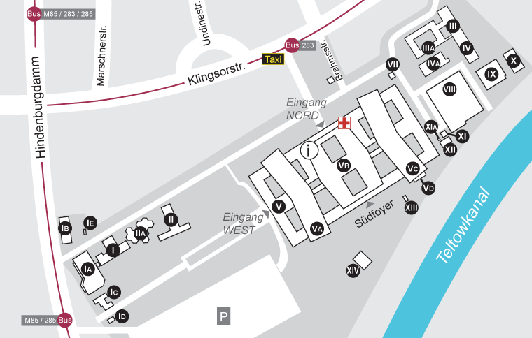

- Library (Bibliothek) (2nd level)

CHARITÉ CAMPUS MITTE (CCM):

Charitéplatz 1
10117 Berlin

How to get there:

- Take U6 til Naturkundemuseum.
- S5,7 or 9 til Hauptbahnhof, then 10 min by foot.

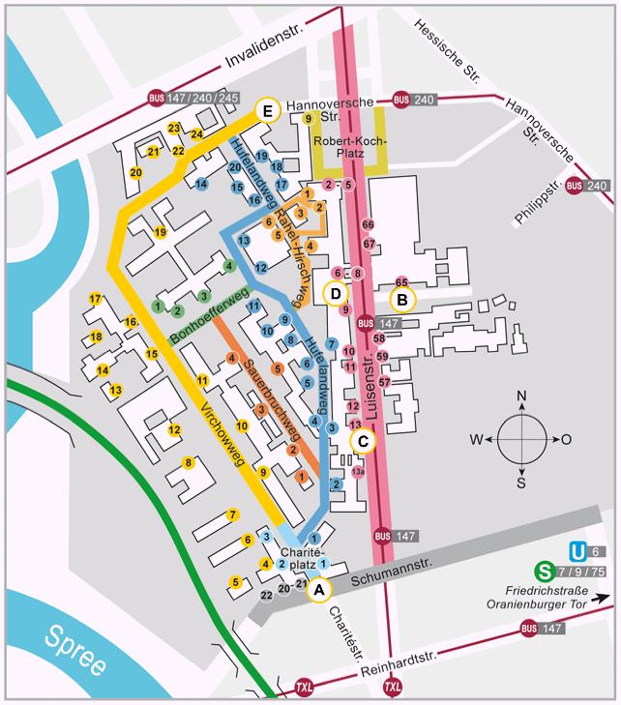

- Charité International Cooperation / Welcome Center [yellow - 24]
- Library (Oskar-Hertwig-Haus, Philippstraße 11/12) [under B]
- CIPOM-Computer room (Lernzentrum Virchowweg 5 Ebene 2) [No. 5 yellow]
- Medical-historical museum [No. 17]

CAMPUS CHARITÉ VIRCHOW KLINIKUM (CVK):

Augustenburger Platz 1
13353 Berlin

How to get there:

- Take U9 (direction: U Rathaus Steglitz) til U Amrumer Straße

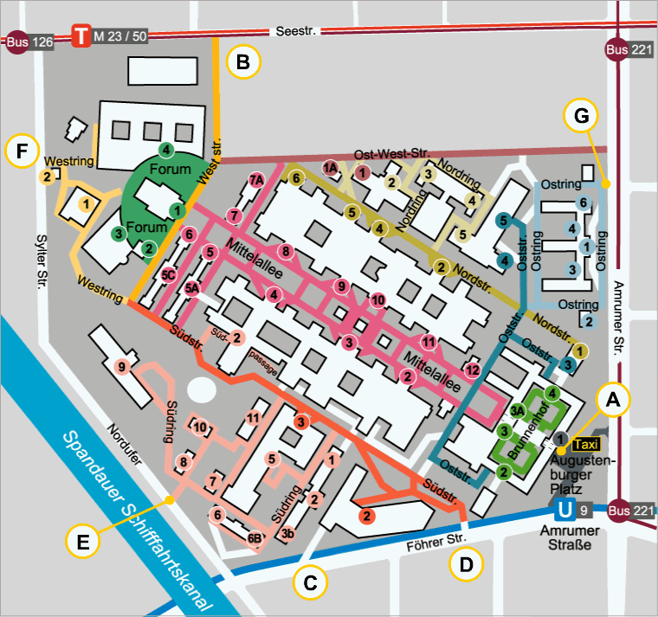

- Library [No. F - 1]
- Refectory [No. B - 3]
- Company doctor [No. E - 6B]
- Lehrgebäude [No. F - 3]

PUBLIC TRANSPORT (U-Bahn, S-Bahn, Bus, Tram):



